**Condition Monitoring - Manufacturing Sector**

GOKULNATH K & E24755

**Overview**

Condition monitoring in the manufacturing sector involves tracking the performance and health of machinery through data analysis to predict equipment failures. A data analyst's role is to process and analyze real-time sensor data, such as temperature, vibration, and pressure, to identify patterns and anomalies. This helps optimize maintenance schedules, reducing unplanned downtime and enhancing equipment lifespan. By applying predictive analytics, condition monitoring improves operational efficiency and lowers maintenance costs.

**Objective**

1. Predict Equipment Failures: Use data analysis to forecast potential machinery breakdowns before they occur.
2. Optimize Maintenance Schedules: Develop data-driven strategies to perform maintenance at the right time, minimizing downtime.
3. Enhance Equipment Lifespan: Identify early signs of wear and tear to prolong the lifespan of machinery.
4. Improve Operational Efficiency: Ensure smooth production processes by preventing unexpected equipment failures.
5. Reduce Maintenance Costs: Implement predictive maintenance strategies to lower repair and replacement expenses.
6. Analyze Sensor Data: Process real-time data (temperature, vibration, etc.) to detect performance anomalies.
7. Increase Overall Equipment Effectiveness (OEE): Boost production efficiency by keeping machinery in optimal condition.

**Assigned Task(s)**

* Condition Monitoring - Manufacturing Sector.
* **Status:** Completed.
* **Details:**

1. Temperature Distribution: A histogram shows the distribution of machine temperature.
2. Vibration by Operational Status: A boxplot displays vibration levels based on operational status.
3. Correlation Matrix: A heatmap reveals correlations between key metrics like temperature, RPM, and vibration.
4. Temperature vs Vibration: A scatter plot visualizes the relationship between temperature and vibration.
5. Machine RPM and Power: A line plot shows RPM and power consumption trends over time for a specific machine.
6. Average Coolant Level: A bar plot shows the average coolant level by machine.
7. Operational Status (Pie Chart): A pie chart displays the distribution of machine operational statuses.
8. Humidity for Maintenance Machines: A histogram compares humidity for machines needing maintenance.
9. Predictive Maintenance: A Random Forest model predicts maintenance needs using machine metrics.

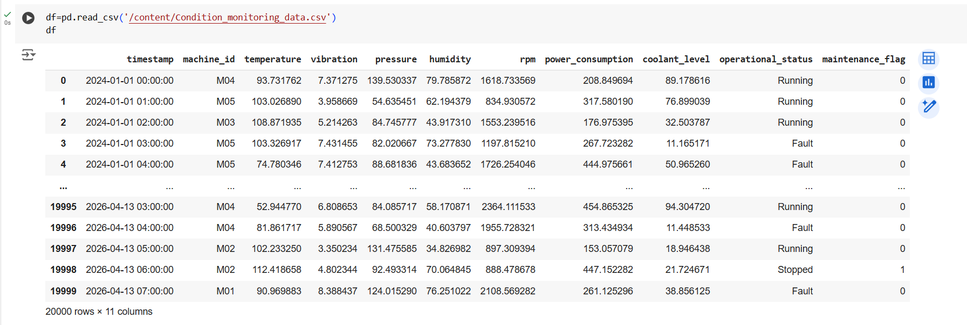

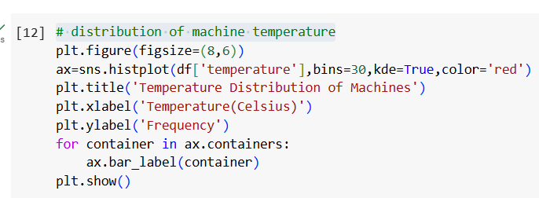

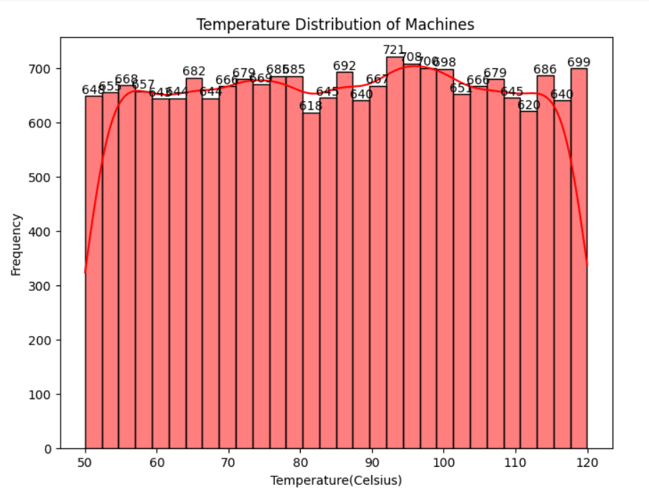

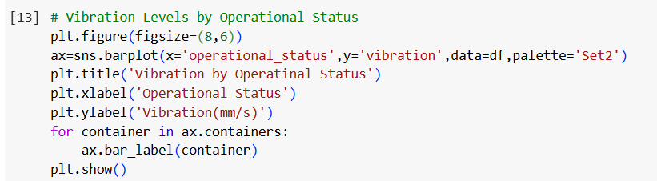

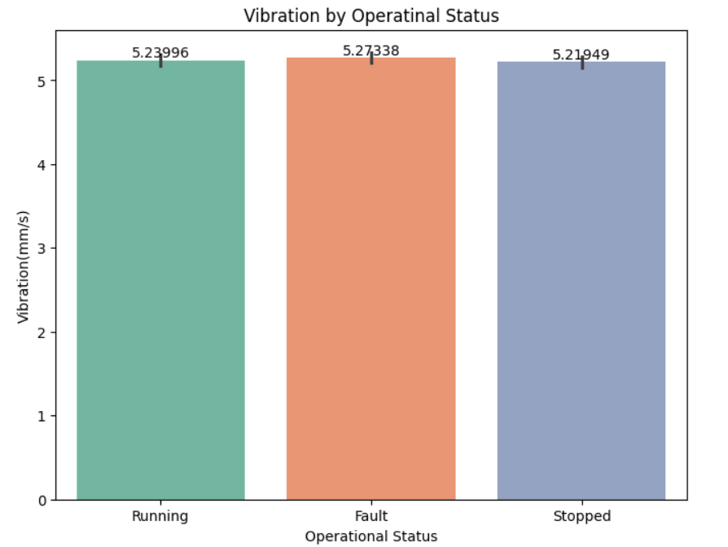

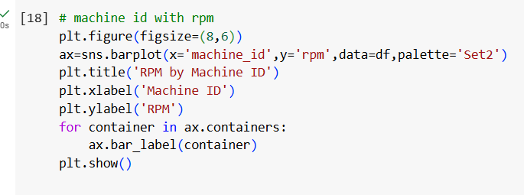

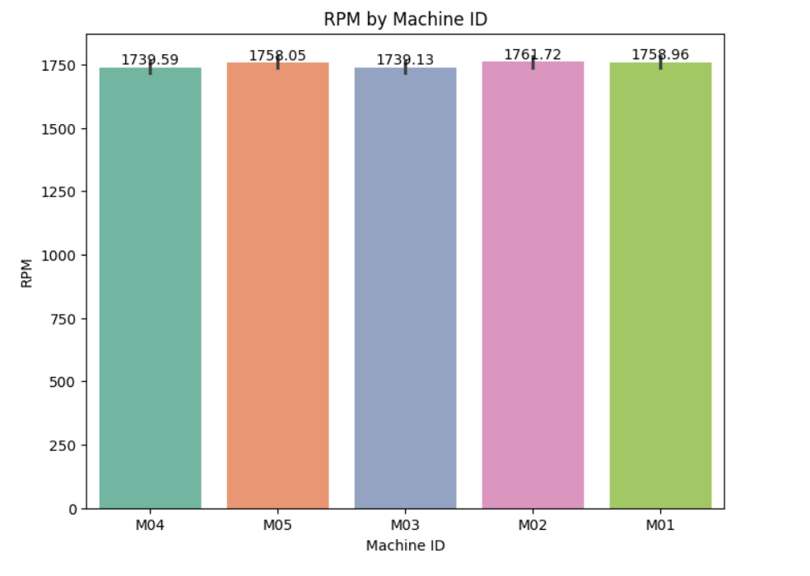

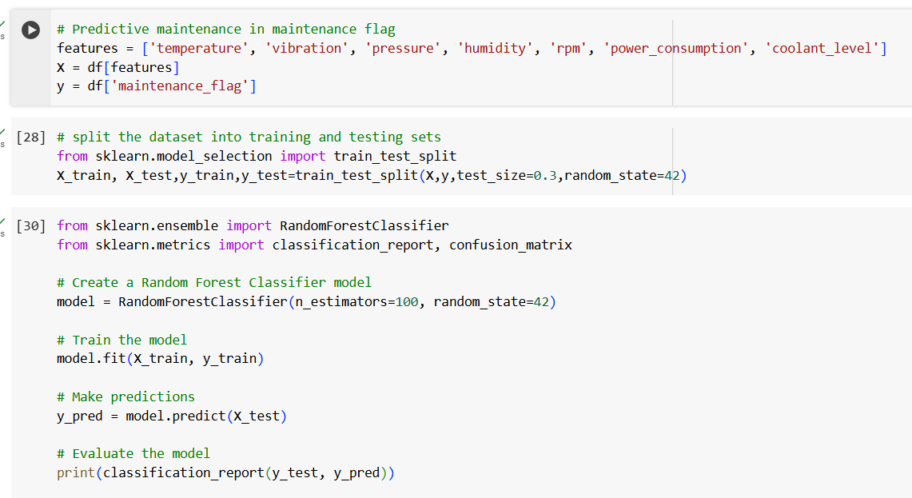

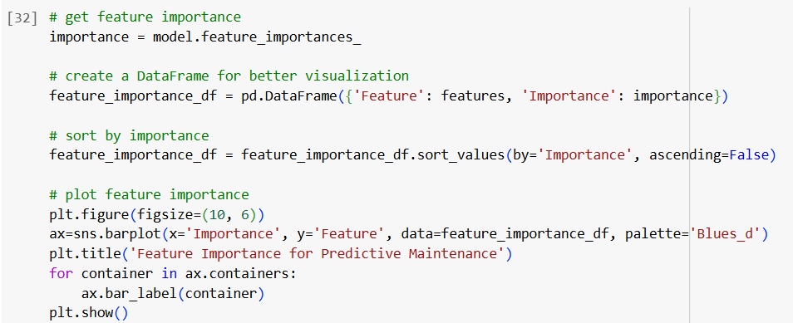

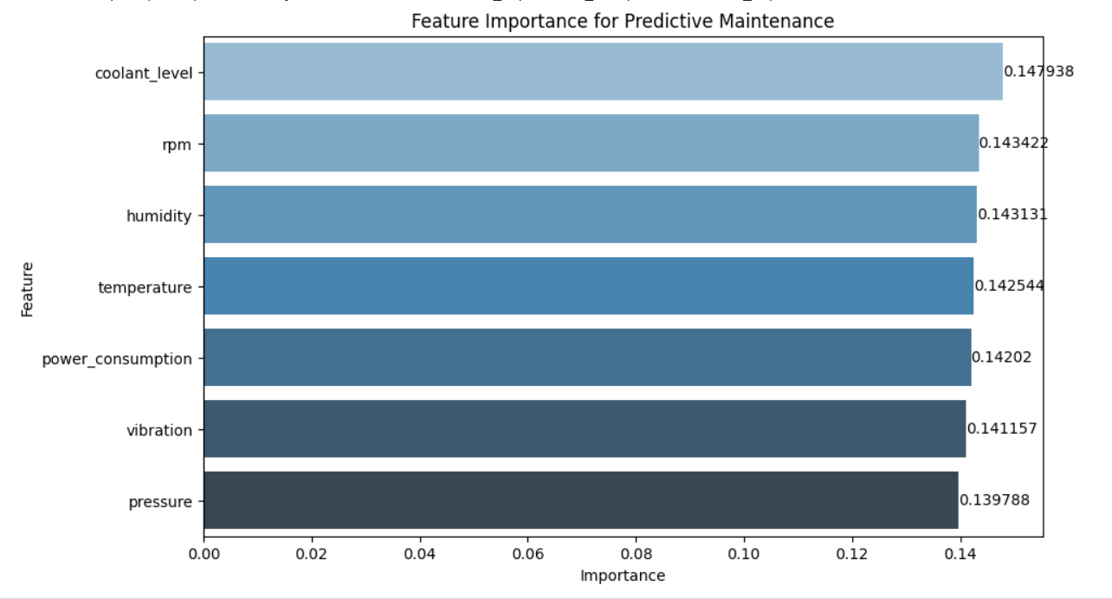

**Progress**

* **Accomplishments:**

1. Temperature Analysis: Visualized machine temperature distribution to identify overheating risks.
2. Vibration Monitoring: Assessed vibration levels by operational status for early fault detection.
3. Correlation Insights: Developed a correlation matrix to reveal relationships between key metrics.
4. Temperature vs Vibration: Investigated the relationship between temperature and vibration with a scatter plot.
5. Performance Tracking: Monitored RPM and power consumption trends to enhance operational efficiency.
6. Coolant Level Evaluation: Analyzed average coolant levels by machine to ensure optimal usage.
7. Operational Status Visualization: Displayed machine operational status distribution using a pie chart.
8. Humidity Comparison: Compared humidity levels for maintenance vs. non-maintenance machines.
9. Predictive Maintenance Model: Implemented a Random Forest model to predict maintenance needs, reducing downtime**.**

* **Metrics:**

1. Temperature Range: Minimum, maximum, and average temperature of machines.
2. Vibration Levels: Average and peak vibration readings across operational statuses.
3. Correlation Coefficients: Values indicating the strength and direction of relationships between metrics.
4. Temperature vs Vibration Correlation: Correlation coefficient specifically between temperature and vibration.
5. RPM Trends: Average RPM values over time, highlighting peak and low usage periods.
6. Power Consumption: Average and peak power consumption for each machine.
7. Coolant Levels: Average coolant level by machine, indicating proper coolant usage.
8. Operational Status Proportions: Percentages of machines in various operational states (Running, Stopped, Fault).
9. Humidity Levels: Average humidity levels for maintenance vs. non-maintenance machines.
10. Predictive Maintenance Accuracy: Model accuracy, precision, recall, and F1-score for maintenance prediction.

**Challenges and Solutions**

* **Challenges Faced:**

1. Incomplete or noisy data can lead to inaccurate analysis and predictions.
2. Difficulty in integrating real-time sensor data for timely decision-making.
3. Managing large datasets and ensuring the model scales with increasing data volume.

* **Solutions Implemented:**

1. Implement robust data preprocessing techniques to handle missing and noisy data.
2. Develop data pipelines to facilitate real-time data integration and processing.
3. Utilize cloud-based platforms for scalable storage and model deployment.

**Next Steps**

* **Upcoming Tasks:** Create detailed process maps to identify inefficiencies and areas for improvement.
* **Goals:** Stay updated on industry trends and technologies to enhance skills and knowledge.

**Conclusion**

* **Summary:** Condition monitoring in the manufacturing sector is vital for maintaining equipment reliability and optimizing operational efficiency. By utilizing data analytics and real-time monitoring, manufacturers can identify potential failures before they occur, reducing unplanned downtime and maintenance costs. This proactive approach enhances decision-making and promotes continuous improvement, ultimately leading to increased productivity and competitiveness in the industry. Implementing effective condition monitoring strategies ensures that resources are utilized efficiently, contributing to overall business success.
* **Acknowledgements:** Thank you all for your attention and engagement, I appreciate your interest in the Condition Monitoring - Manufacturing Sector.

### 